Installing, Configuring, and Uninstalling Citrix Workspace on Chrome OS Devices

**Contents**

Installing Citrix Workspace on Chrome OS Devices ............................................................. 2

Configuring Citrix Workspace on Chrome OS Devices.......................................................... 3

Secondary configuration of Citrix Workspace on Chrome OS Devices…………………. 6

Uninstalling Citrix Workspace on Chrome OS Devices ......................................................... 9

**Installing Citrix Workspace on Chrome OS Devices**

1. On the Chrome OS device, open the **Chrome Web Store** and search for ‘Citrix Workspace’. Select ‘Citrix Workspace for Chrome OS’. Click **Add to Chrome** and **Add App** When prompted.

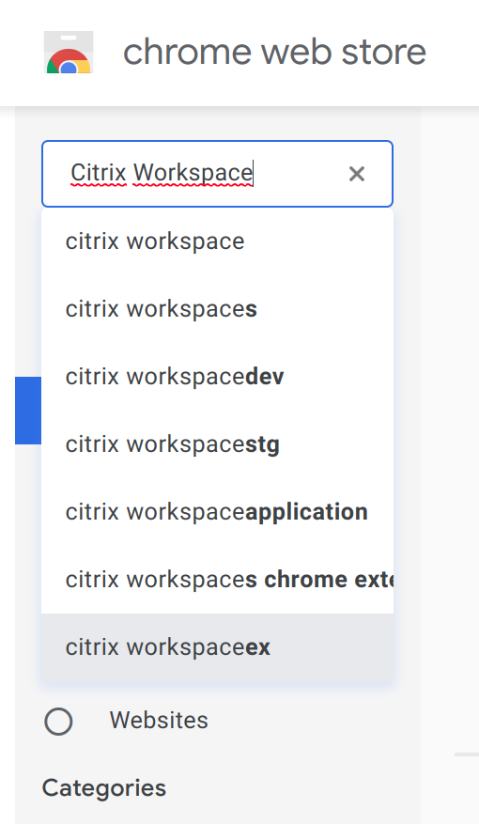

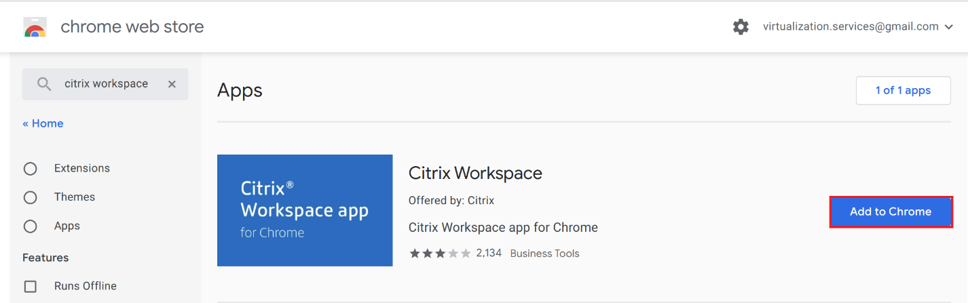

**Configuring Citrix Workspace on Chrome OS Devices**

1. Upon installation, click the Launcher Icon and then click the **Citrix Workspace** icon. You may need to click on All Apps to see the Citrix Workspace icon.

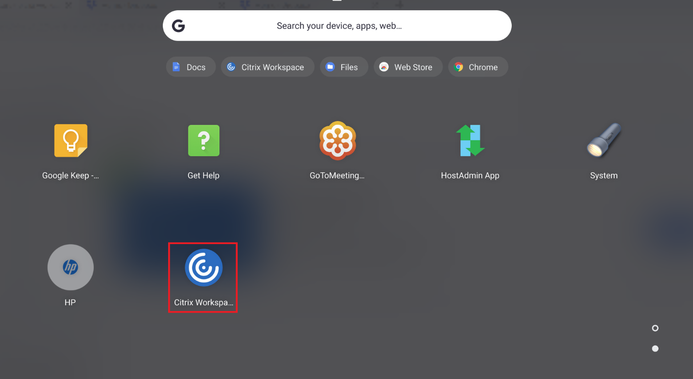

1. You will be prompted to enter a server address: Enter <https://www.myapps-duke-energy.com>

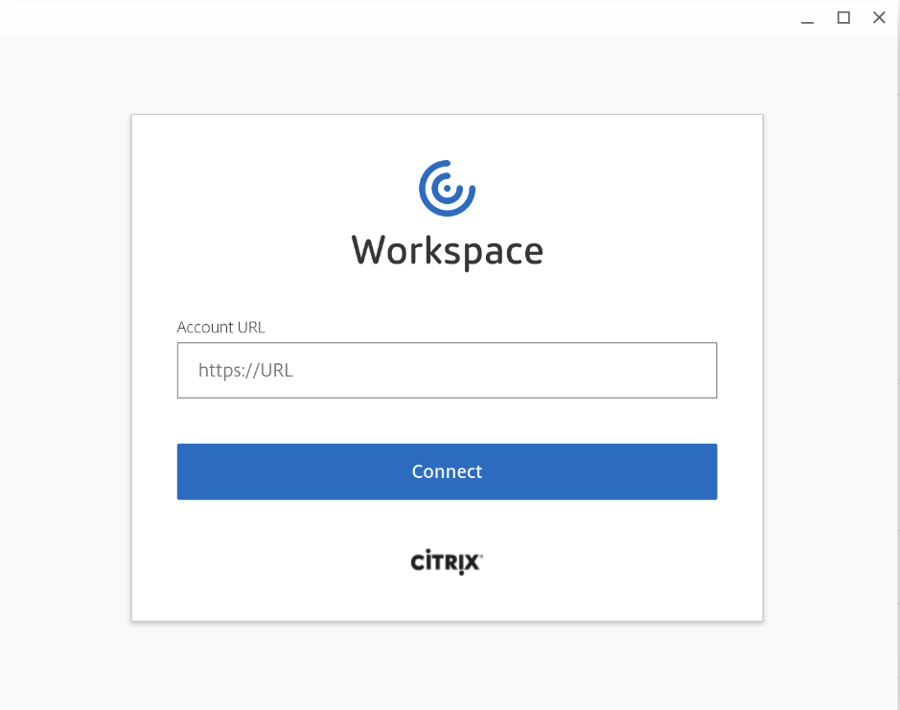

1. Next, enter your **Username**, **Password** and your **Passcode** when prompted. Click **Log On** once you’ve finished entering your information.

**NOTE**:

• When using a **physical key fob**, your **Passcode** is your **unique PIN + RSA token ID.**

• When using a **soft token,** the PIN is not included as part of the Passcode.

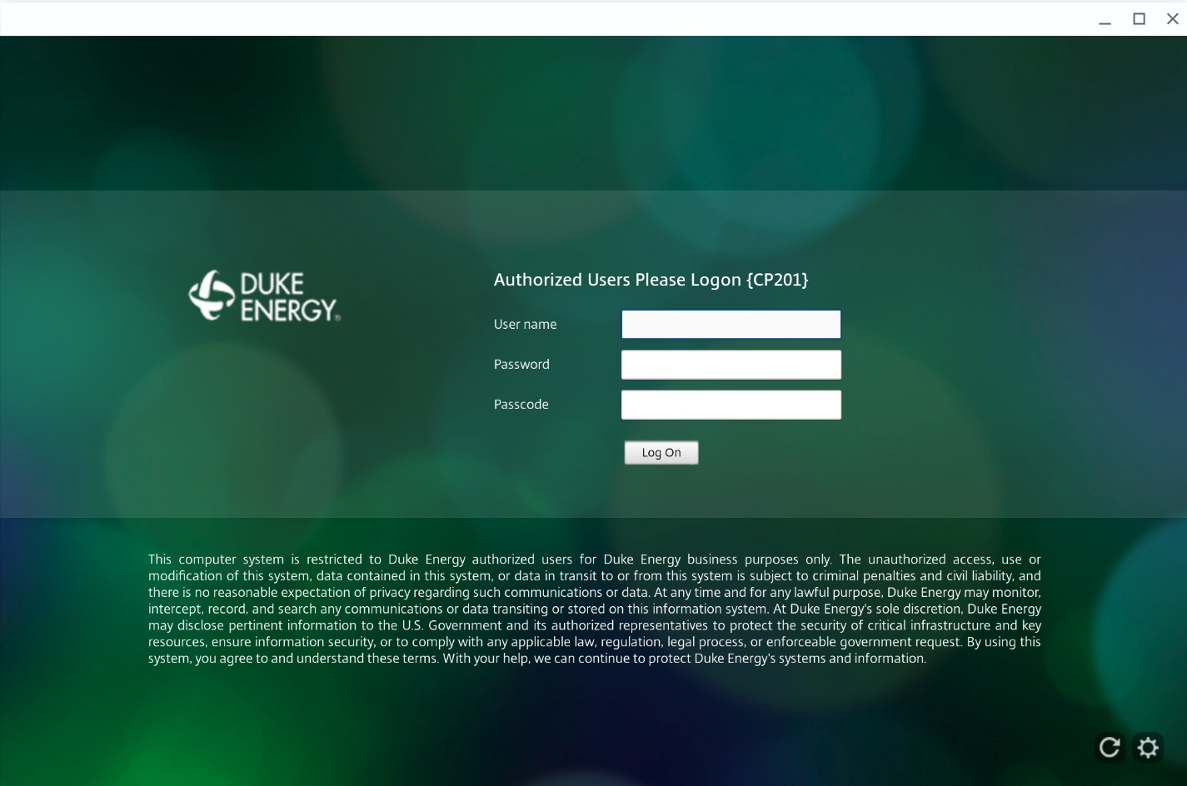

1. The available Citrix applications and desktops should now appear as icons. You have successfully installed the Citrix Workspace software on your computer.

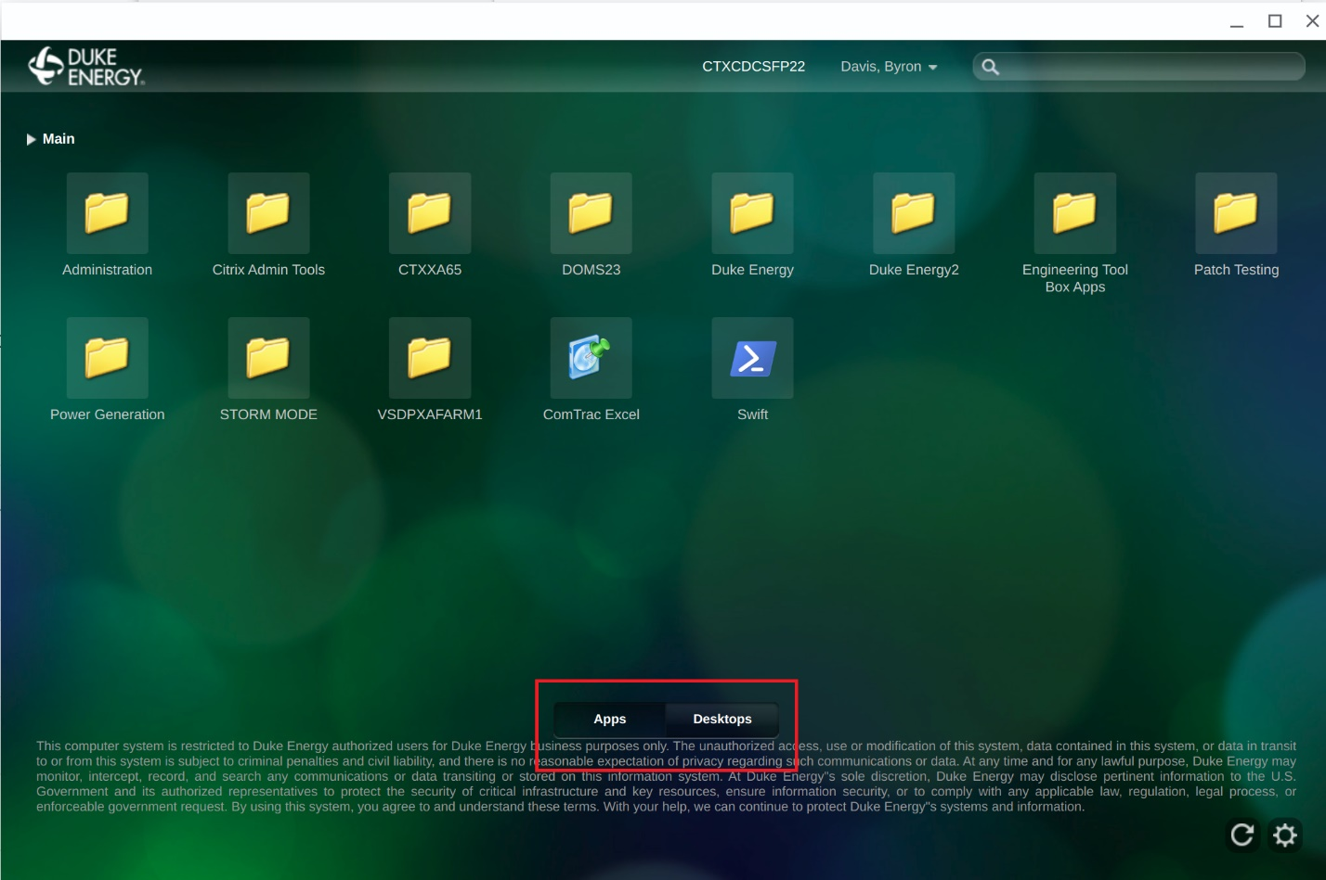

1. To launch a virtual desktop, select the **Desktops** tab at the bottom of the screen and select the assigned desktop. And to launch a virtual application, select the **Apps** tab at the bottom of the screen and select the application.

**Secondary configuration of Citrix Workspace on Chrome OS Devices**

**NOTE**: If you have not set up an authentication method in O365, by using this job aid [How to Add or Change your O365 Profile Authentication method](https://dukeenergy.sharepoint.com/:b:/r/sites/O365Help/Shared%20Documents/Create%20or%20change%20your%20O365%20Authentication%20Profile.pdf?csf=1&e=Ppj4Kx), please do so **BEFORE** adding the Multifactor Authentication Citrix Portal URL

* + Be sure you set up a **primary** authentication method and a **secondary** authentication method.
    - Your office phone may automatically pre-fill; HOWEVER, be sure to **uncheck this option**. Your primary and secondary methods should be a combination of: a mobile phone number, secondary mobile phone number, a home phone number where you will be working or the [Authenticator application](https://dukeenergy.sharepoint.com/:b:/r/sites/portal/our-company/cybersecurity/Technical%20Resource%20Center/Authenticator%20App%20setup.pdf?csf=1&e=oqjrUH)
    - The **Authenticator application** is the **preferred primary** method of authentication.
  + Choose your **preferred primary authentication method** from the drop-down box under “what’s your preferred option?”

1. Upon installation, click the Launcher Icon and then click the **Citrix Workspace** icon. You may need to click on All Apps to see the Citrix Workspace icon.

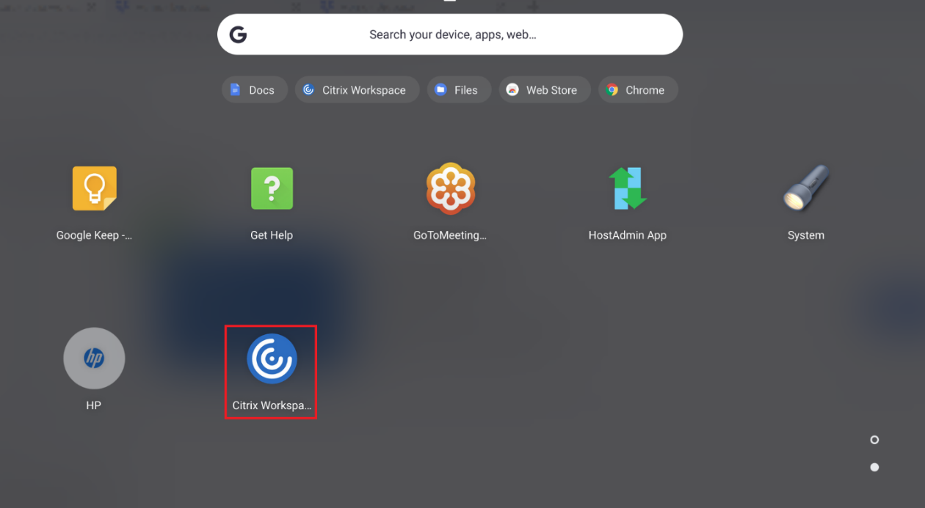

1. You will be prompted to enter a server address: Enter <https://www2.myapps-duke-energy.com/Citrix/Duke-Energy-MFAWeb/> in order to setup the Citrix Portal that utilizes Multifactor Authentication. Afterwards, select **Connect.**

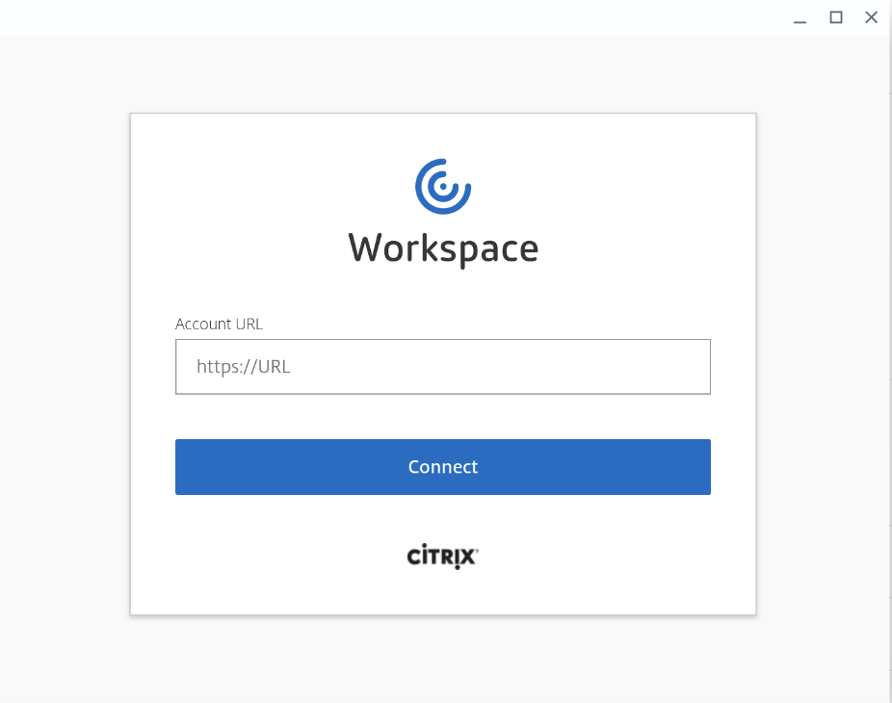

1. Next, enter your **Username** and **Password** when prompted. Click **Log On** once you’ve finished entering your information.

**NOTE**: You will be prompted to authenticate via the method that you setup within your Office 365 Authentication Profile:

* Via a call to a phone number you provided during setup (e.g., mobile phone number, secondary mobile phone number, or home phone number where you will be working)
* The Microsoft Authenticator application 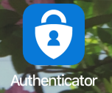

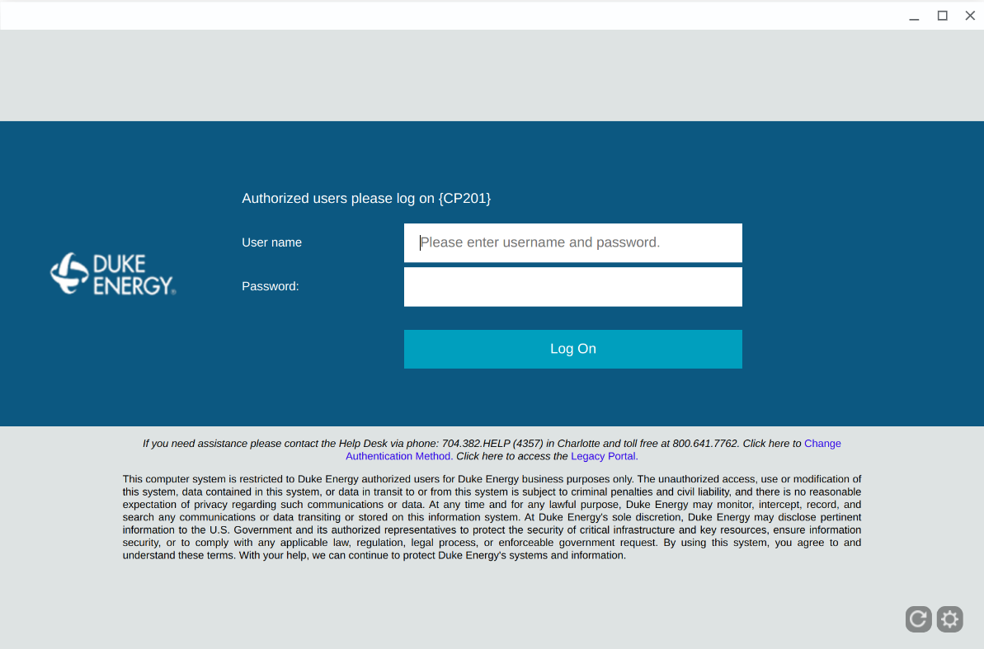

1. To access your assigned virtual desktops or virtual applications, click either the **DESKTOPS** or **APPS** buttons at the top of the page.

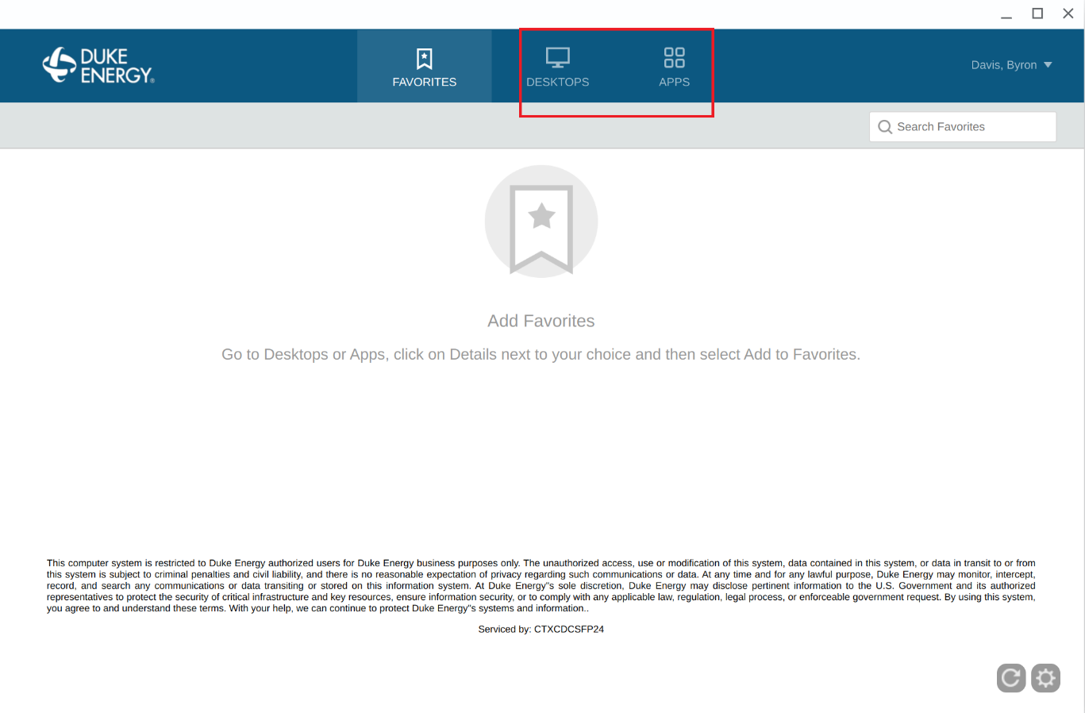

**Uninstalling Citrix Workspace on Chrome OS Devices**

1. Open the Launcher (Magnifying glass) on your taskbar. Click the upward arrow to show all installed apps and locate the Citrix Workspace icon.
2. Right-click the Citrix Workspace Icon. If you are not using a mouse, then press the Alt key when you click on the Citrix Workspace icon to bring up the ‘right click’ menu options
3. Click **Uninstall.** Click **Remove** when asked to confirm removal.

